Unit 4 File Server Explanation

**Corey Crooks**

**Purdue University Global**

**IT332 – Principles of Information Systems Architecture**

**Jonathan Abramson**

**July 30th, 2023**

There’s quite a lot that goes into buying components for a system. The first step, however, is to decide the requirements. It has come to my attention that this is a small business that is expecting an overhead of roughly 40-50 concurrent users. Being a small business, that number may shrink or grow to an unknown capacity as business ramps up, although at this moment in time, we will develop this system with 40-50 users in mind. These components may be upgraded at a later date, or a new system installed, should the demand outgrow the operational capabilities of these recommendations. It is important to note that this is not necessarily a guide on building this system entirely; it is moreso a simple recommendation of major components. Things like cooling, and optimal server placement will not be included, but may be vital to consider for the effective operation of this system.

**CPU**

CPU architecture has developed quite a long way in recent time. Today, there are many different architectures targeted to many different end-users. For example, a simple desktop CPU may have minimal multithreading support, since applications like Microsoft Word, Google Chrome, or one of the various Windows tools may not require this functionality (San Jose State University, n.d.). On the other hand, certain CPU architecture may include multithreading performance, and come with a various count of both cores and threads in multitudes that cannot be seen in typical consumer hardware (San Jose State University, n.d.). For the purposes of this discussion, we will only be looking at server architecture. Due to the high influx of expected users, it will make sense to utilize server-dominant technology and methodologies such as a reliance on hyperthreading, multithreading, and increases in both physical and logical cores. In the section below, you may see a readout of similar CPU architecture from Intel and AMD for a full comparison, but overall I would recommend a Ryzen 3950X. This CPU is a decent balance between high performance, and low cost. Due to the relatively low user count compared to IoT based servers, this business does not require the blistering performance of something like an Intel Xeon CPU Max 9480, but requires more output than a budget desktop CPU like the Intel Pentium Gold G6400

**Memory**

Although there is no necessarily “simple” component in a system, memory itself can be the most straightforward to compare. Memory can come in many different sizes, although the profile is usually standardized (The University of New Mexico, 2016).The amount of RAM you can utilize in your system may depend on a number of factors from the CPU architecture you run, the Motherboard’s physical capacity, or even the Operating System that is helping the entire system run together (The University of New Mexico, 2016). There are a few ways to distinguish which RAM modules may be best for a given system other than the up-front cost of the set. For example, DRAM (Dynamic Random Access Memory) comes with different speeds, and different timings. Different generations of DDR memory run at different speeds. Generally, a DDR2 memory module can be outperformed by a DDR3 memory module, and so on. The unit of this measurement is commonly in Mega Transfers per second (MT/s)—detailing the speed at which data can move through the module (The University of New Mexico, 2016). Timings are also an important detail to discuss, as they may determine the overall latency of a memory module, often determined by CAS Latency. As told by the memory manufacturer Micron, the format for displaying the latency would be A-B-C-D. A here is the time for a memory module to have data ready at request. B is the time for a read in that memory after it is prepared. C is the time it takes for memory to have a new row ready for extra data. D is the time required for a row to be ready for access (Crucial by Micron, 2023). Occasionally, manufacturers will only give the CAS Latency of a module (the A value). Server architecture utilizes a type of memory module that crucially increases the stability of the system it is attached to by implementing Error Correcting Code (Chin-Lung Su, 2005). This protocol can eliminate potential issues with the data going through the module, and thus maximize the total up-time of the entire system as a whole; which is vital for a business to function.

With all this considered, the memory module package that I would recommend would be the Kingston Fury Renegade Pro. Capacity is an important consideration in selecting the right memory module, and although the G.SKILL Zeta R5 Series module is considerably faster than my recommended module, the capacity of the recommendation is unmatched in this lineup. I do not believe that the difference in timings nor speed of the modules will make as much of a difference as the total capacity will for a small business of this size.

**Storage**

Storage is the last of the recommendations I may provide in this document, as all other topics are simply technological implementations, or decided by the business needs itself. We have already talked about a kind of volatile storage with RAM modules, but storing data for the long term requires another solution. This solution comes in two main forms: Hard Drives, or Solid-State Drives. Hard Drives are more reliable without constant use, but can be quite a bit slower than their Solid-State counterpart (University of San Diego, 2016). Due to the nature of this machine, I believe Solid-State drives would be the most appropriate option. Drive speed is a huge factor in the system’s operating capacity, and given that ideally this machine would be on and running for a good portion of the day, every operating day, the charge state degradation of individual SSD’s cells would not realistically pose a problem enough to warrant an HDD integration (Mai Zheng, n.d.).

My recommendation in this category may be a little unorthodox. I would recommend one Samsung 990 PRO. Unfortunately this is not enough storage to handle the needs of this business, so I would recommend an additional 3.84 TB Kingston DC 600M drive. This will ultimately give you nearly 5 TB of data capacity, which should be well more than enough for 50 active users. I wouldn’t recommend a single Kingston 7.68 TB drive simply due to the nature of SSD failure; adding a second drive may provide more stability, as there is still a storage solution active should one fail. Additionally, should the motherboard selection permit it, multiple M.2 SSD’s such as the Samsung may be run at the same capacity along with RAID methodology to increase stability and data preservation in the event of drive failure (Peter Chen, 1994).This could be an extremely compelling option, should the budget allow it.

**Bus**

The PCIe Bus is the main way your computer may interact and communicate with one another. Essentially, it acts as the nervous system of a machine. This Bus can be rated by PCIe generation, and total bandwidth in Gigabits per second noted as Gbps (Gilbert, 2010). Although there is no really shopping guide to look at for a PCIe bus, since it is built into your computer’s motherboard, it is an important concept to understand when you are looking at a system in terms of modular functioning parts.

**DMA**

Direct Memory Access is an optimization in the way data may be written to and from memory. The memory bus can be utilized to send information from the disk, to the main memory module. The CPU could take data from the disk to the memory module to itself. To optimize this process, a DMA controller can be utilized to essentially remove the need for the CPU to oversee this operation (Aater Suleman, n.d.). The DMA will store information to interact with the memory module, and do so over the memory bus. This allows the CPU to perform more operations, and due to the CPU’s cache, the inactive periods of the bus may be more utilized by the DMA controller to make the operation overall more efficient.

**Interrupts**

Interrupts are a vital process in modern digital computing. Essentially, interrupts do as the name suggests; it allows the system to stop a given process in favor of something with greater importance (Bates, n.d.). One common manual interrupt in Windows machines would be the key combo CTRL+ALT+DELETE. This sends an interrupt through the operating system to allow the user to perform administrative actions without needing the current process to complete.

**Input/Output Peripherals**

Of all the sections on this list, peripherals are by far the most varied. In today’s computing landscape, there is a computer peripheral for nearly everything the user may need. As it is, a peripheral has one or both of two functions, but can be classified in either: and input peripheral, or an output peripheral (Swarthmore College, n.d.). Common examples of Input peripherals may be computer mice, keyboards, and even touchpads. Output peripherals could include monitors, televisions, audio equipment and more.

**Monitor**

A monitor is a nearly essential part of a computer system today. Providing the user with feedback to their actions is the first basic step in an interactive system. You can’t do this without either audio, touch, or visuals. Computer monitors capture the visual aspect of this by providing a display as an output from your computer, but sometimes may also have built-in speakers to give an audio component as well. Monitors are specific calibers of displays geared towards desktop computers, and generally include a different software suite than that found in television sets. (Slippery Rock University, 2014). Although there are plenty of machines like server solutions and automation controllers that don’t have displays, it is rare to find a system that doesn’t include either a monitor, or T.V.

**Tables**

CPU:

|  |  |  |  |  |
| --- | --- | --- | --- | --- |
| **Model** | Intel Pentium Gold G5400 | AMD Ryzen 3950X | Intel Xeon E-2334 | Intel Xeon CPU Max 9480 |
| **GHz** | 3.70 | 3.50-4.7 | 4.80 | 1.90-3.50 |
| **Cores** | 2 | 16 | 4 | 56 |
| **Threads** | 4 | 32 | 8 | 112 |
| **Cache** | 4MB | 64MB | 8MB | 112.5MB |
| **Max RAM capacity** | 64GB | 128GB | 128GB | 4TB |
| **Price** | $64 | $249 | $281 | $12,980 |
| **Source** | (Intel, 2023) | (Advanced Micro Devices, Inc, 2023) | (Intel, 2023) | (Intel, 2023) |

Memory:

|  |  |  |  |
| --- | --- | --- | --- |
| **Module** | Visiontek Adrenaline | Kingston Fury Renegade Pro | G.SKILL Zeta R5 Series |
| **Capacity** | 1x 2GB | 4 x 32GB | 4 x 16GB |
| **MT/S** | 800 | 5600 | 6400 |
| **Timings** | CL: 5 | CL: 36 | 32-39-39-102 |
| **ECC capable?** | No | Yes | Yes |
| **Price** | $27.99 | $698.99 | $499.99 |
| **Source** | (VisionTek, 2023) | (Kingston, 2023) | (G.SKILL, 2023) |

Storage:

|  |  |  |  |  |
| --- | --- | --- | --- | --- |
| **Drive** | Samsung 990 PRO | Kingston DC1000B | Kingston DC 600M | Kingston DC 600M |
| **Capacity** | 2TB | 960GB | 3.84TB | 7.68TB |
| **Read** | 7450 MB/s | 3400MB/s | 560MB/s | 560MB/s |
| **Write** | 6900 MB/s | 925MB/s | 560MB/s | 560MB/s |
| **Integration Factor** | M.2 | M.2 | SATA | SATA |
| **Price** | $134 | $112.99 | $317.99 | $641.99 |
| **Source** | (Samsung, 2023) | (Kingston, 2023) | (Kingston, 2023) | (Kingston, 2023) |

**System Diagram**

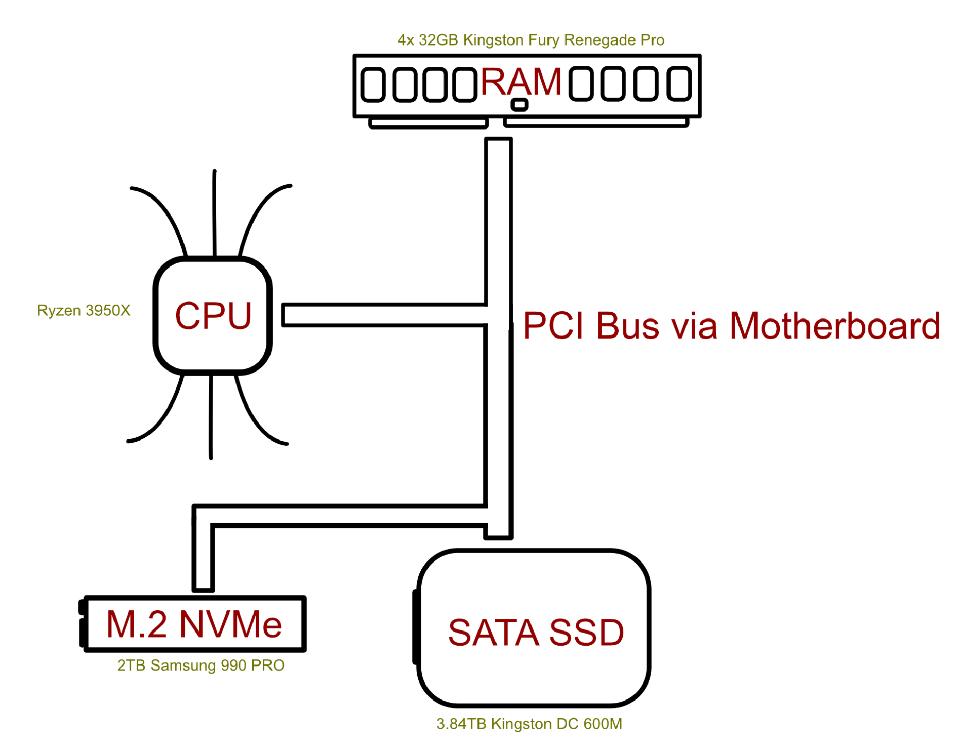

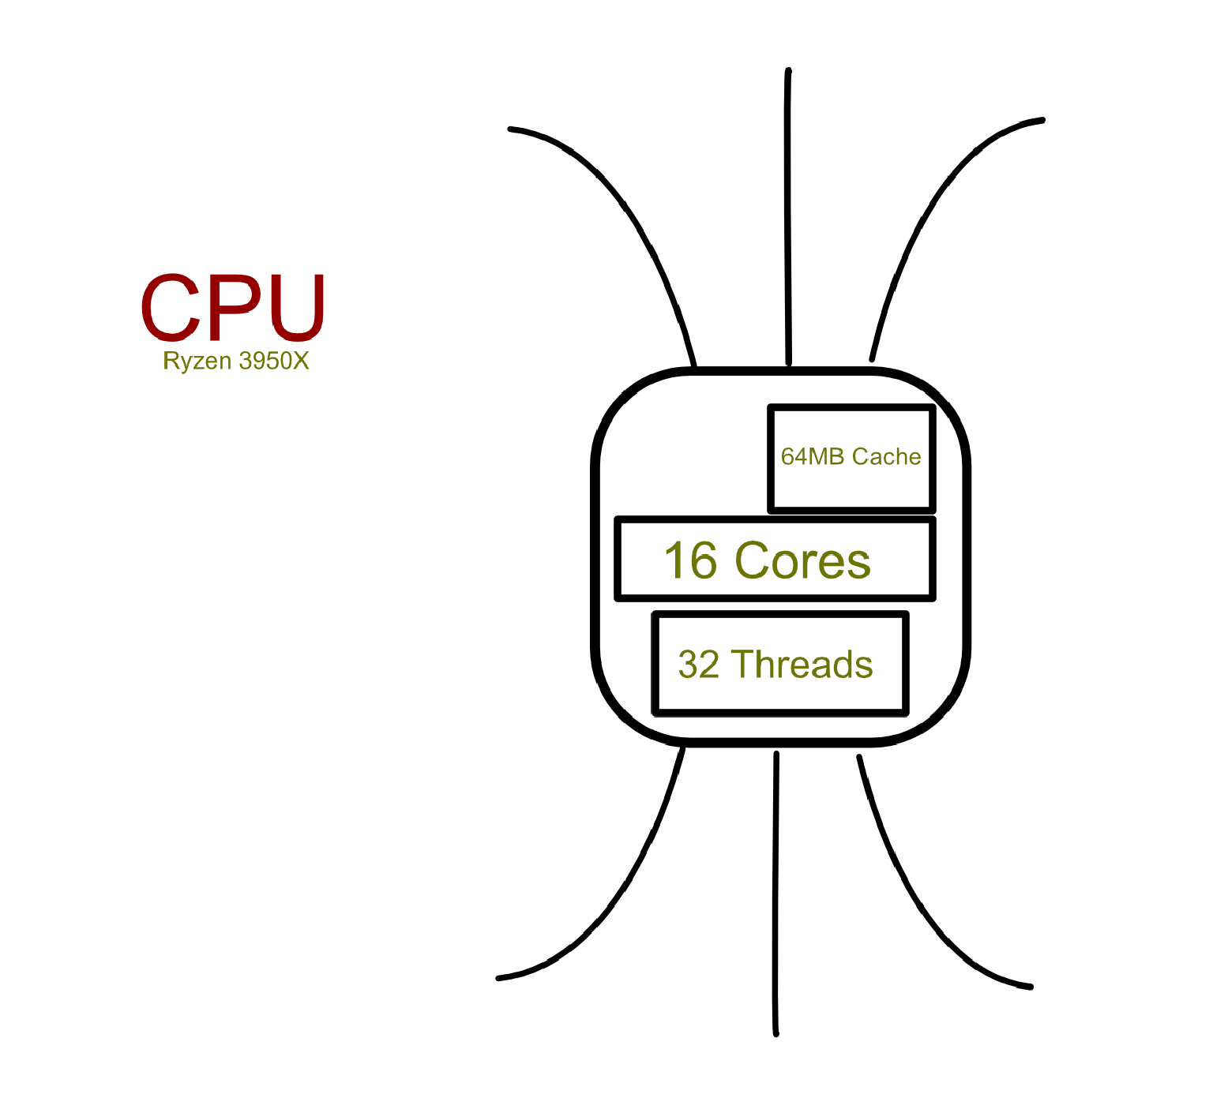

# **References**

Aater Suleman, T. R. (n.d.). *Implementation of a Direct Memory Access Controller*. Retrieved from University of Texas: https://hps.ece.utexas.edu/people/suleman/class_projects/soc_lab3.pdf

Advanced Micro Devices, Inc. (2023, September 4). *AMD Ryzen 9 3950X*. Retrieved from amd.com: https://www.amd.com/en/press-releases/2019-11-07-amd-introduces-world-s-most-powerful-16-core-consumer-desktop-processor

Bates, A. (n.d.). *Operating System Design: Interrupts*. Retrieved from The Grainger College of Engineering: https://courses.engr.illinois.edu/cs423/sp2019/slides/05-interrupts.pdf

Chin-Lung Su, Y.-T. Y.-W. (2005). *An Integrated ECC and Redundancy Repair Scheme for Memory Reliability and Enhancement*. Retrieved from department of Electrical Engineering: https://citeseerx.ist.psu.edu/viewdoc/download;jsessionid=68FAECD601D7927512736E2B1DA5B252?doi=10.1.1.679.9333&rep=rep1&type=pdf

Crucial by Micron. (2023). *What are memory timings?* Retrieved from crucial.com: https://www.crucial.com/support/articles-faq-memory/what-are-memory-timings

G.SKILL. (2023, September 4). *G.SKILL Zeta R5 Series 64GB (4 x 16GB) ECC Registered DDR5 6400 R-DIMM (PC5 51200) Server Memory Model F5-6400R3239G16GQ4-ZR5K*. Retrieved from newegg.com: https://www.newegg.com/g-skill-64gb/p/N82E16820374462

Gilbert, H. (2010, February 13). *The Bus (PCI and PCI-Express)*. Retrieved from Yale University: https://pclt.sites.yale.edu/bus-pci-and-pci-express

Intel. (2023, September 4). *Intel® Pentium® Gold G5400 Processor*. Retrieved from intel.com: https://www.intel.com/content/www/us/en/products/sku/129951/intel-pentium-gold-g5400-processor-4m-cache-3-70-ghz/specifications.html

Intel. (2023, September 4). *Intel® Xeon® CPU Max 9480 Processor*. Retrieved from intel.com: https://www.intel.com/content/www/us/en/products/sku/232592/intel-xeon-cpu-max-9480-processor-112-5m-cache-1-90-ghz/specifications.html

Intel. (2023, September 4). *Intel® Xeon® E-2334 Processor*. Retrieved from intel.com: https://www.intel.com/content/www/us/en/products/sku/212258/intel-xeon-e2334-processor-8m-cache-3-40-ghz/specifications.html

Kingston. (2023, September 4). *Kingston Data Center DC1000B - SSD - 960 GB - PCIe 3.0 x4 (NVMe)*. Retrieved from CDW Marketplace: https://www.cdw.com/product/kingston-data-center-dc1000b-ssd-960-gb-pcie-3.0-x4-nvme/6390766?pfm=srh#TS

Kingston. (2023, September 4). *Kingston Fury Renegade Pro 128GB (4 x 32GB) ECC Registered DDR5 5600 (PC5 44800) Memory (Server Memory) Model KF556R36RBK4-128*. Retrieved from newegg.com: https://www.newegg.com/kingston-128gb/p/N82E16820242787

Kingston. (2023, September 4). *kingston SEDC600M/3840G*. Retrieved from CDW Marketplace: https://www.cdw.com/search/storage-hard-drives/solid-state-drives/?lfr=1&w=KE&key=kingston+SEDC600M%2f3840G

Mai Zheng, J. T. (n.d.). *Understanding the Robustness of SSDs under Power Fault*. Retrieved from The Ohio State University and HP Labs: https://6826.csail.mit.edu/2017/papers/fast13-final80.pdf

Peter Chen, E. L. (1994, June). *RAID: High-Performance, Reliable Secondary Storage*. Retrieved from ACM Computing Surveys: https://web.eecs.umich.edu/~mozafari/fall2015/eecs584/papers/raid-chen.pdf

Samsung. (2023, September 4). *990 PRO PCIe® 4.0 NVMe™ SSD 2TB*. Retrieved from samsung.com: https://www.samsung.com/us/computing/memory-storage/solid-state-drives/990-pro-pcie-4-0-nvme-ssd-2tb-mz-v9p2t0b-am/

San Jose State University. (n.d.). *Multithreading (Under Construction)*. Retrieved from cs.sjsu.edu: http://www.cs.sjsu.edu/faculty/pearce/java1/threads/Multithreading.html

Slippery Rock University. (2014, January). *Peripheral and I/O Hardware*. Retrieved from sru.edu: http://cs.sru.edu/~mullins/cpsc100book/module04_peripheralHardware/module04-03_peripheralHardware.html

Swarthmore College. (n.d.). *Peripherals and busses*. Retrieved from swarthmore.edu: https://www.cs.swarthmore.edu/~kwebb/cs31/s15/bucs/peripherals.html

The University of New Mexico. (2016, August 29). *Computer Concepts and Terminology*. Retrieved from unm.edu: https://www.unm.edu/~tbeach/terms/memory.html

University of San Diego. (2016, March 4). *Have You Upgraded to a Solid State Drive?* Retrieved from sandiego.edu: https://sites.sandiego.edu/

VisionTek. (2023, September 4). *Visiontek Adrenaline 2GB DDR2 SDRAM Memory Module*. Retrieved from newegg.com: https://www.newegg.com/visiontek-2gb-240-pin-ddr2-sdram/p/N82E16820367016